

**Steps Tracker**

**Project Overview**

Step counter project that tracks the steps by the shaking of micro:bit. Will also show the number of steps tracked. You can get a cool flashing heart effect for every 20 steps. We are using Blocks from Microsoft MakeCode editor to program. Easy and simple.

**Goals Addressed**

* **Goal 1. Logical Systems**
  + Program the Micro:bit to using Blocks from Microsoft MakeCode editor to track the number of steps
* **Goal 15. Product Prototyping**
  + Build a functional prototype for steps tracking

**Why It’s Fun and useful**

* **Visual Feedback:** The micro:bit's LED display makes it fun to see the number of steps visually displayed and track progress in real-time.
* **Simple and Creative:** Using Microsoft MakeCode’s Blocks editor is beginner-friendly and lets users unleash their creativity without getting bogged down by complex coding.
* **Customizable:** Users can personalize the project, such as changing the animation, step threshold for rewards, or adding sounds, making it more engaging.

**Steps to create the steps tracker**

**Step 1: Assemble Your Tools**

* A Micro:bit.
* A battery pack for portability.
* Access to the or Python editor.

**Step 2: Code Your Micro:bit**

1. **A blue and black rectangular object with white text

   Description automatically generated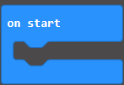We need to set our blocks:**  
   from :

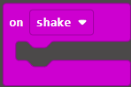  
  
  
 from :  
  
  
   
 from we need to set a new variable by click on called “Steps” then

 click

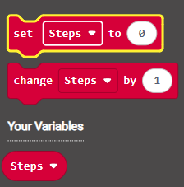 Now New Block appears:

Now The Blocks space should be like this:

1. **A red and blue rectangular box with white text

   Description automatically generatedSet the Steps by Zero**:  
   From Chose the drag it into [On Start] Block to be like this:
2. **A blue rectangular box with white text

   Description automatically generated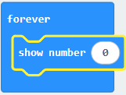Show the number in the LEDs:**  
   From Chose then drag it into [Forever] Block to be like this  
     
      
     
     
     
   and From chose then drag it into the Zero inside [Show Number] Block to be like this:
3. 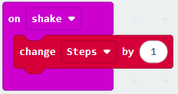**Setting up the shacking command:**  
   From chose drag it into [Shack] Blockto be like this:

From chose drag it into [Shake] Block, under like this:



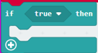

From chose drag it into “true” to be like this:

From chose but inside the 0 variable and change

number 1 to 20 to be like this then drag it here

to be like this:

**** From chose drag inside [if] Block, under drag , then drag and and to be like this :

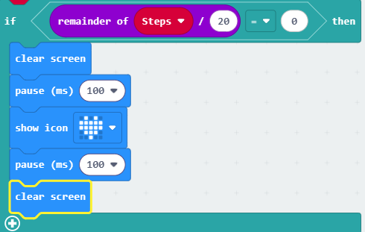

Now we have finished the code, Your code should be like this:

Plug your micro:bit into the computer then press